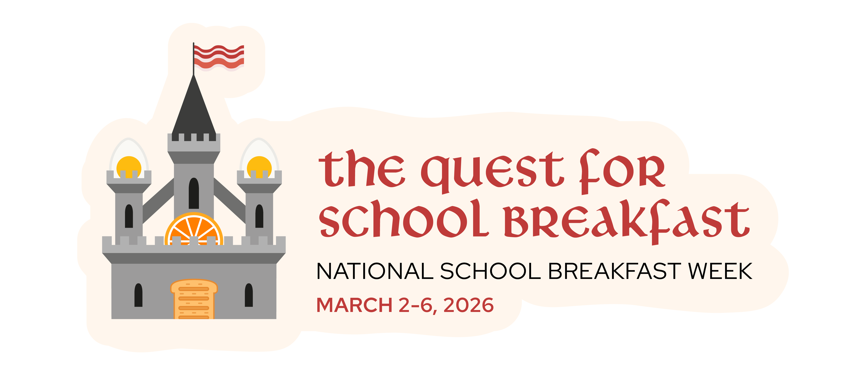
NATIONAL SCHOOL BREAKFAST WEEK OFFICIAL PROCLAMATION

WHEREAS The School Breakfast Program has served our nation admirably since it was permanently established in 1975; and

WHEREAS the School Breakfast Program is dedicated to the health and well-being of our nation’s children; and

WHEREAS the School Breakfast Program joins and has been joined through the years by many
other excellent child nutrition programs; and recent research shows students are
receiving their healthiest meals at school; and

WHEREAS there is evidence of continued need for nutrition education and awareness of the value
of school nutrition programs

NOW THEREFORE, I ___________________________________________ of the ____________________________________
of ______________________________ do hereby proclaim the week of March 2-6, 2026, as NATIONAL SCHOOL BREAKFAST WEEK and I encourage all residents to become aware of the benefits of the School Breakfast Program and support good nutrition habits for their children, in the hope of achieving a more healthful citizenry for today and the future.

IN WITNESS WHEREOF, I have hereunto set my hand and caused the Official Seal of the _______________________
___________of _____________________________ to be affixed.

Done at the ________________ this ____________ day of ______ in the year, Two Thousand and Twenty-Five.

ATTEST: ______________________________ [STATE SEAL]

