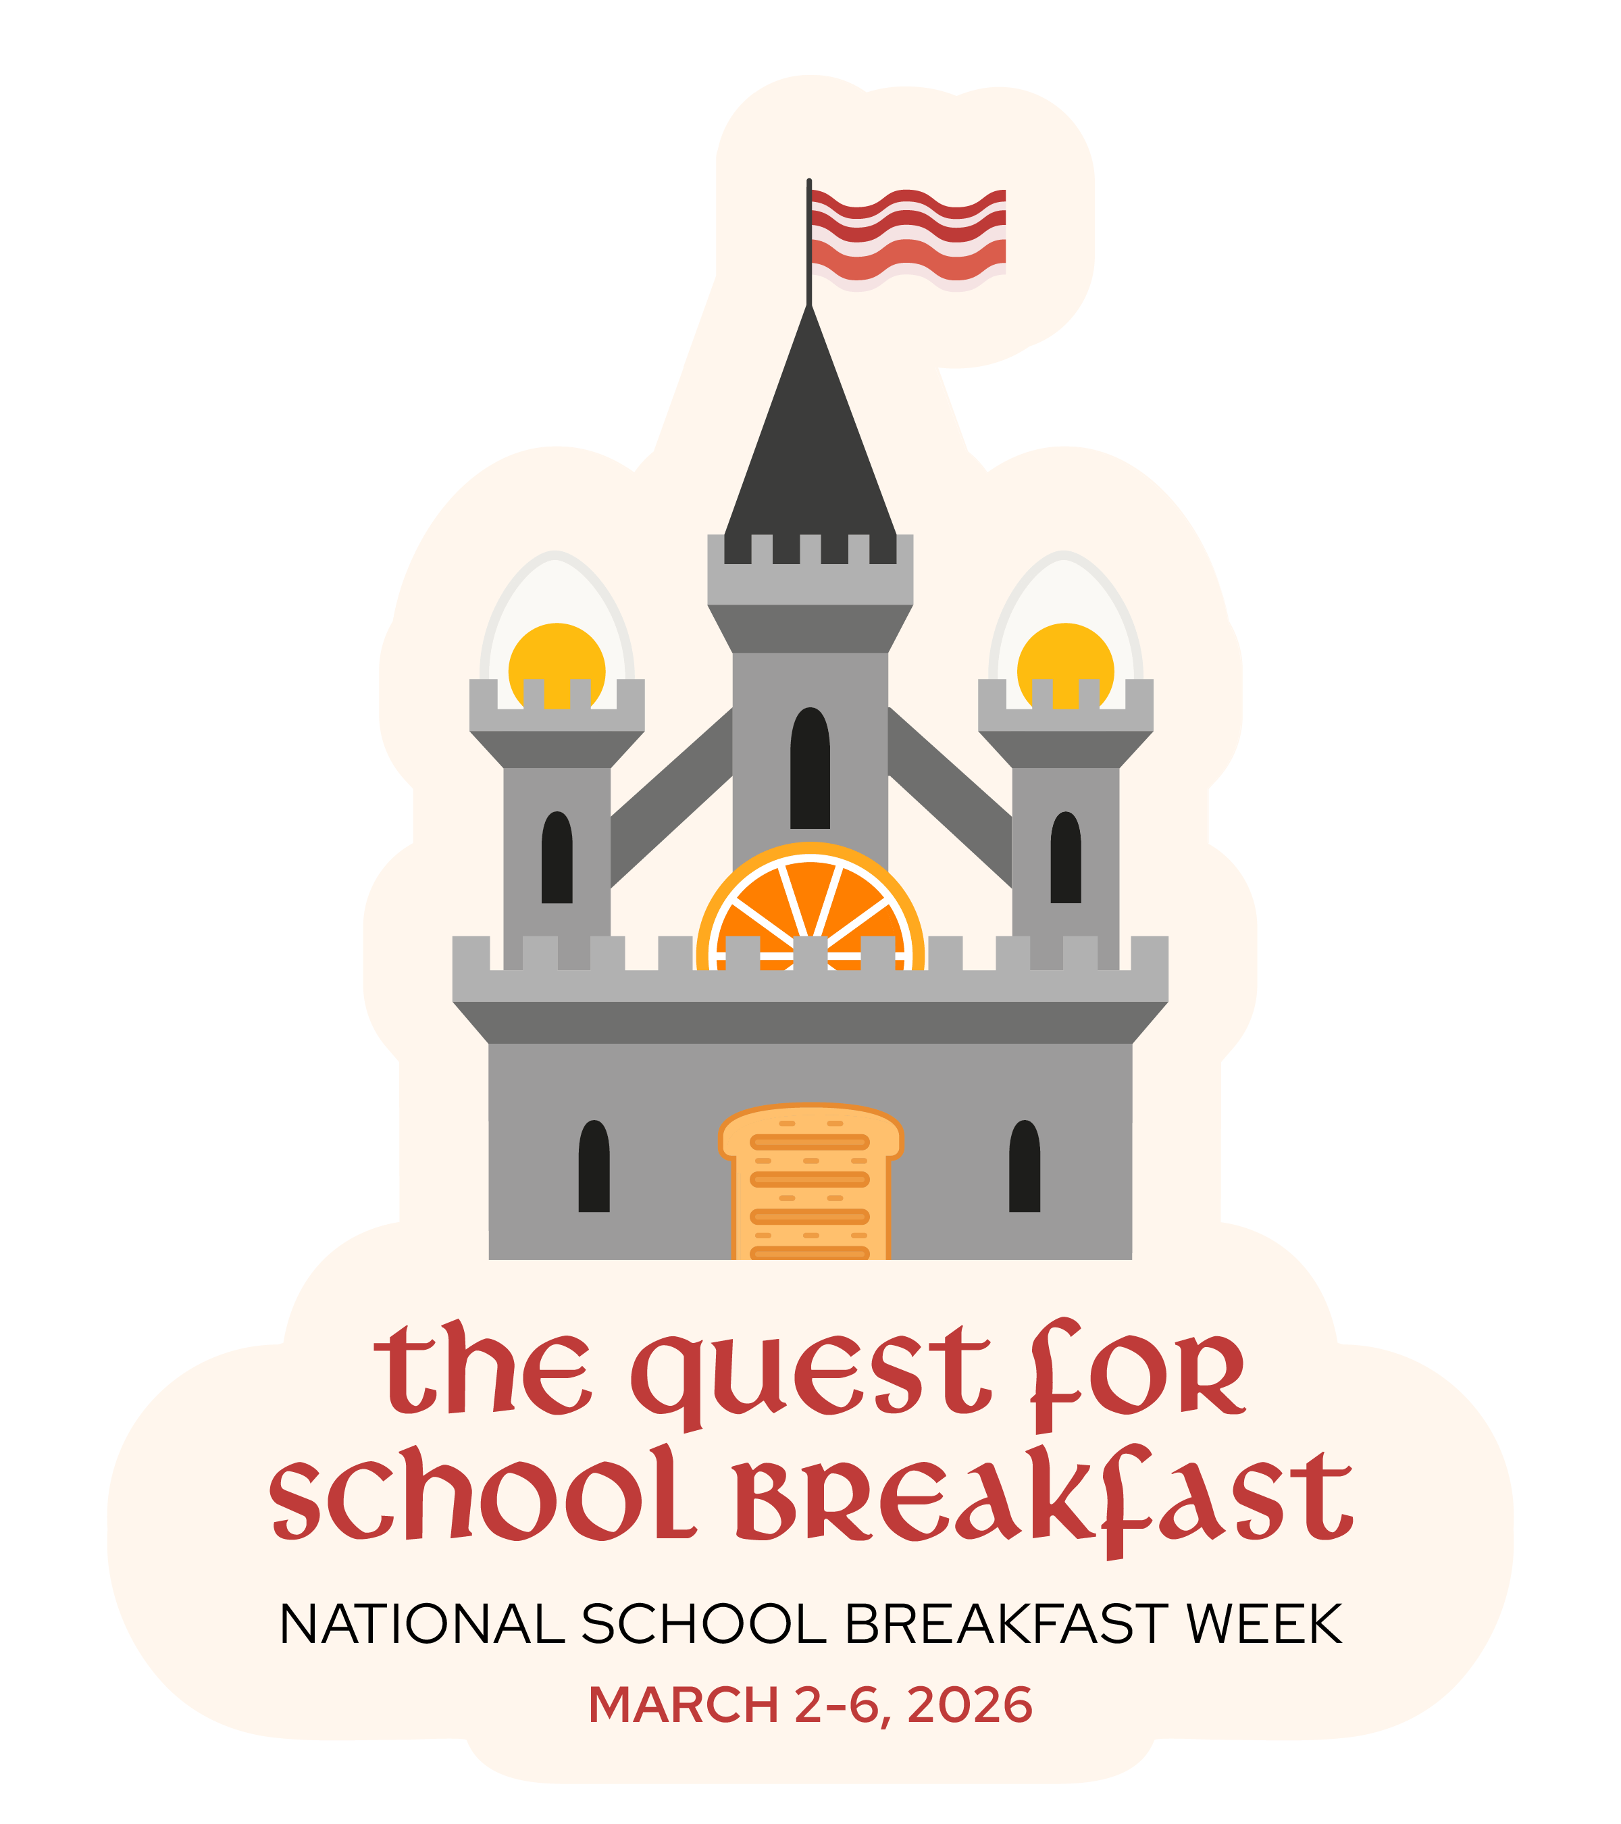
FOR IMMEDIATE RELEASE

Media contact:
[SNA Member name]
[Phone]
[Email]

The Quest For School Breakfast
National School Breakfast Week Campaign Encourages Students to Try School Breakfast

[CITY, STATE] –[MONTH] [DATE], 2026 – To encourage more families to take advantage of the healthy choices available with school breakfast, [District] schools will celebrate National School Breakfast Week (NSBW) during March 2-6, 2026.

Busy weekday mornings make it a challenge for many families to find time for a healthy breakfast. Fortunately, [District] schools offer nutritious school breakfasts, complete with fruit and low-fat or fat-free milk, to ensure students are fueled for learning every school day. [Insert details about how your program is offering school breakfast this year].

The 2026 NSBW campaign theme, “The Quest For School Breakfast,” reminds the entire school community that school breakfast provides a healthy and energizing start to the day for students. Studies show that students who eat school breakfast are more likely to:

- Reach higher levels of achievement in reading and math
- Score higher on standardized tests
- Have better concentration and memory
- Be more alert
- Maintain a healthy weight

School nutrition professionals and students will be encouraged to show their enthusiasm for school breakfast from March 2-6 as the district celebrates NSBW with special menus, activities, and more. [Insert details on your planned activities for NSBW26 meal plans and/or date and time of special NSBW events.]

“A healthy breakfast at the start of the day is a great way to ensure students are nourished and ready to learn,” said [Director name, title here]. “National School Breakfast Week helps us educate parents and students about all the nutritious and delicious choices we offer.”

[Insert details about specific healthy foods served during NSBW and throughout the year. Also, mention if your program is increasing participation via different service models like Breakfast in the Classroom or Grab and Go Breakfast.]

About National School Breakfast Week

National School Breakfast Week was launched in 1989 to raise awareness of the availability of the School Breakfast Program, a federally assisted meal program operating in public and non-profit private schools and residential child care institutions since 1975.

