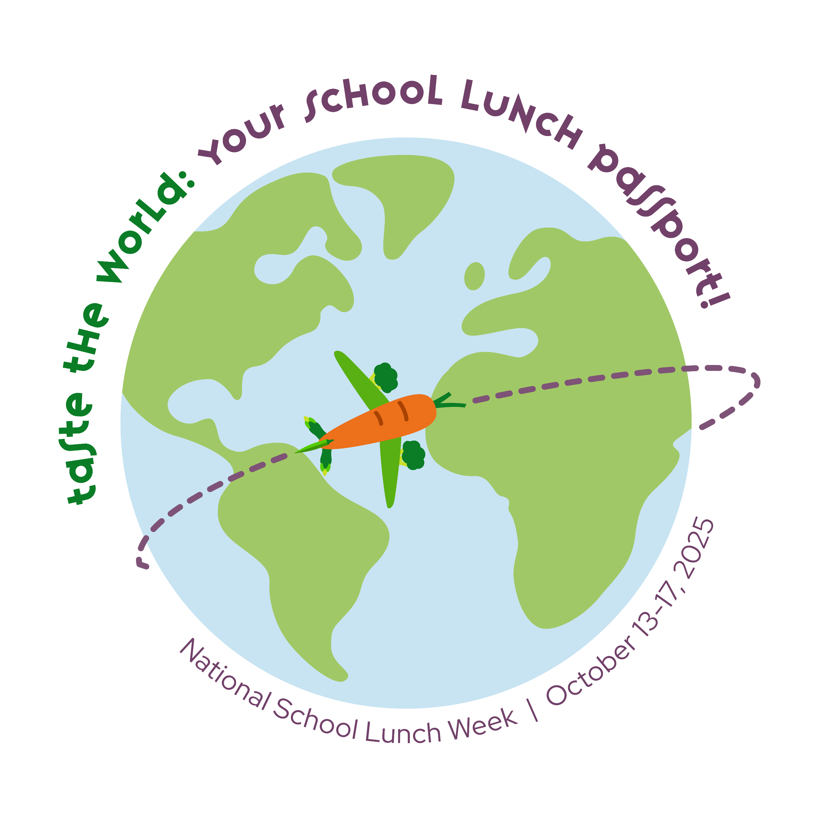
National School Lunch Week Official Proclamation

WHEREAS The National School Lunch Program has served our nation admirably for 79 years through advanced practices and nutrition education; and

WHEREAS the National School Lunch program is dedicated to the health and academic achievement of our nation’s children, and

WHEREAS recent research shows students are receiving their healthiest meals at school; and
there is evidence of the continued need for nutrition education and awareness of the
value of school nutrition programs.

NOW THEREFORE, I _____________________________ of the ______________________
of ______________________________ do hereby proclaim the week of October 13-17, 2025, as NATIONAL SCHOOL LUNCH WEEK and I encourage all residents to become aware of the benefits of the National School Lunch Program and support good nutrition habits for their children, in the hope of achieving a more healthful citizenry for today and the future.

IN WITNESS WHEREOF, I have hereunto set my hand and caused the Official Seal of the ______
___________of _____________________________ to be affixed.

Done at the ________________ this ____________ day of ______ in the year, Two Thousand and Twenty-Five.

ATTEST: ______________________________ [STATE SEAL]

