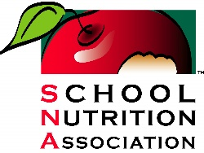
School Nutrition at a Glance
*Data is based on SY _______________

Name:
Email Address:
Phone Number:
City: | State: |  | Congressional District:
School District Name:
Number of Schools in District:
District Enrollment Size:
Annual Budget:
Unpaid Meals Balance:
 |  | Breakfast |  | Lunch
Average Daily Participation (ADP):
ADP in SY 21-22:
ADP in SY 22-23:
% Free and Reduced Students Served:
SY22-23 Reimbursement Rates for Free Meals:
(Includes KKFA temporary increase through July 2023 only)

Cost to Produce Meal:
% Increase of Costs:
Staffing Challenges: % staffed
Impact of the end of the temporary KKFA reimbursement:

Impact of the end of meals at no cost, or if applicable, benefit of continuing meals at no cost:

