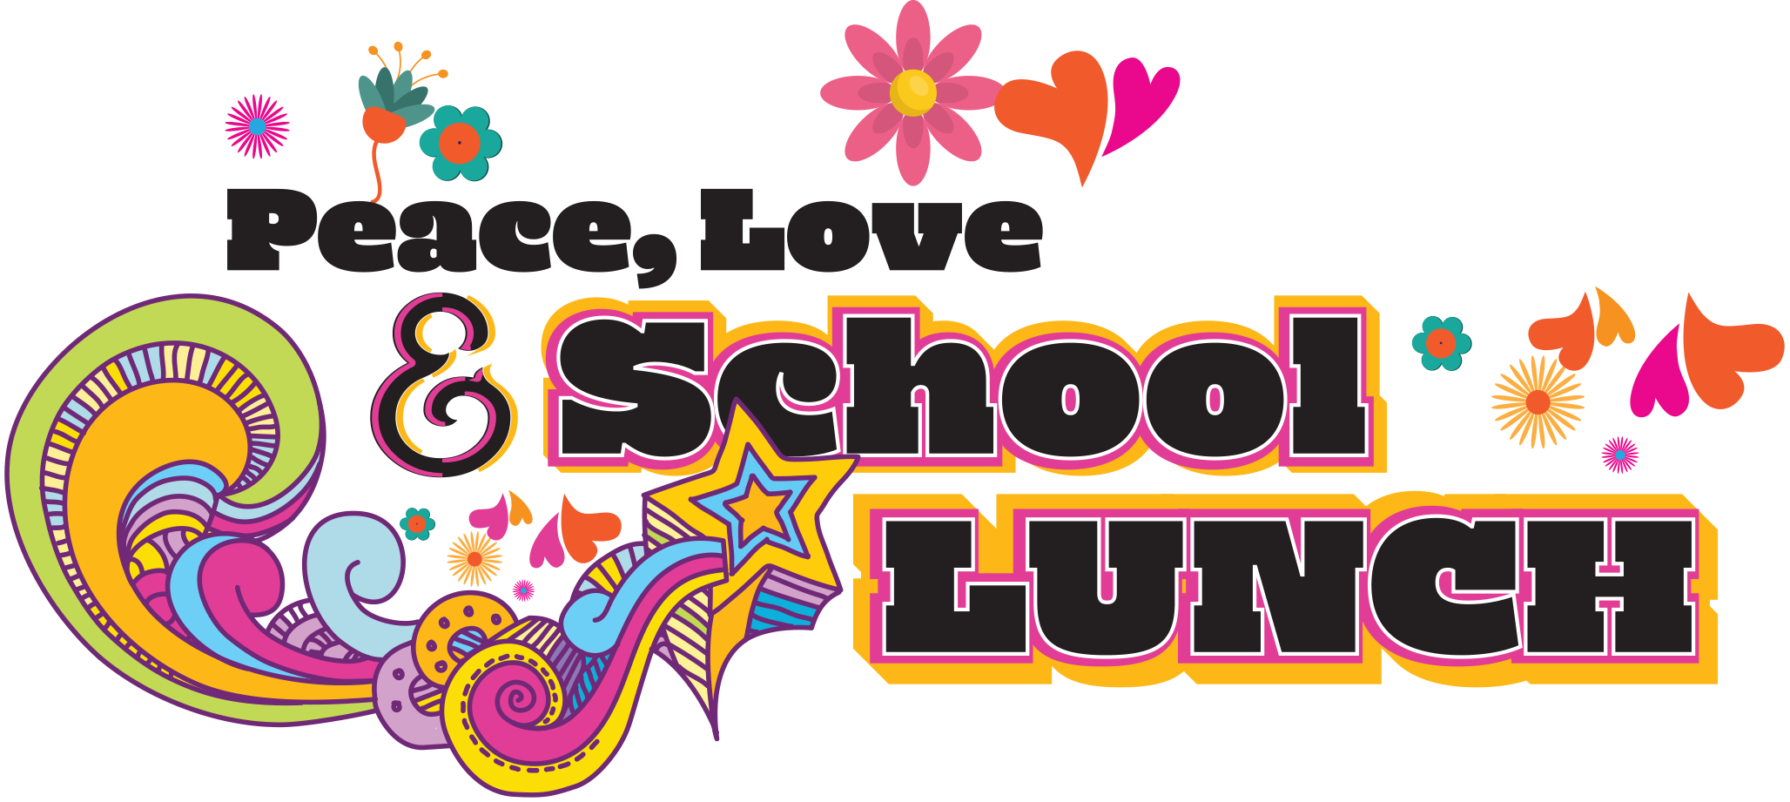

For Immediate Release

[District] Schools Celebrate National School Lunch Week
“Peace, Love & School Lunch” Campaign highlights #NSLW22

(CITY, STATE) – October [XX], 2022 – To recognize the National School Lunch Program, serving nearly 30 million children each day, [District] schools will celebrate National School Lunch Week from October 10-14, 2022. The fun and creative campaign theme, “Peace, Love & School Lunch,” highlights the importance of a healthy school lunch to a student’s success both in and out of the classroom.

Research shows children are getting their healthiest meals at school. National School Lunch Week will highlight the nutritious foods available daily at [District’s] schools. [Insert details about specific healthy foods served during NSLW and throughout the year. Include details about how your program is helping educate kids about healthy choices and physical activity.]

“School lunches offer students fruits and vegetables, whole grains and milk, and meet federal nutrition standards limiting fat, calories and sodium,” said [Director name, title]. “National School Lunch Week helps us educate parents and students about all the wonderful benefits of our lunch program.”

[Insert details on your planned activities for “Peace, Love & School Lunch,” meal plans and/or date and time of special NSLW events.]

The federally funded National School Lunch Program (NSLP) has been fueling students for success for 75 years. [Insert details about meal prices – e.g., Students can enjoy the convenience of a healthy school lunch for just $X.XX elementary, $X.XX middle and $X.XX high school.] Some students may qualify for free or reduced-price meals. Contact xxx to learn out more.]

The “Peace, Love & School Lunch” campaign is made possible by the nonprofit School Nutrition Association and Kellogg’s. Parents and students can follow the fun on social media using the hashtags #NSLW22, #PeaceLoveSchoolLunch and #SchoolLunch.

For more information on National School Lunch Week, visit [District nutrition program website] [and/or] https://schoolnutrition.org/nslw/.

[INSERT YOUR SCHOOL DISTRICT BOILER PLATE LANGUAGE HERE]

###

